**SQL CASE STUDY**

**BURGER BASH**

**Name: S. Nikhil Sai**

**Date: 9-11-2024**

use burger_bash;

CREATE TABLE burger_names(

burger_id INTEGER NOT NULL PRIMARY KEY

,burger_name VARCHAR(10) NOT NULL

);

INSERT INTO burger_names(burger_id,burger_name) VALUES (1,'Meatlovers');

INSERT INTO burger_names(burger_id,burger_name) VALUES (2,'Vegetarian');

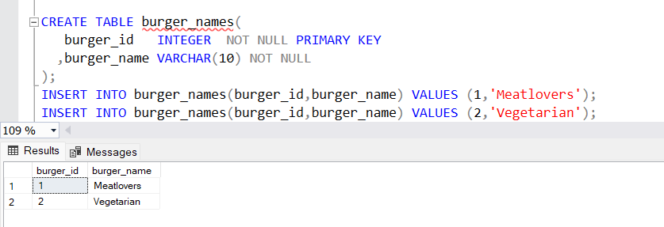

CREATE TABLE runner_orders(

order_id INTEGER NOT NULL PRIMARY KEY,

runner_id INTEGER NOT NULL,

pickup_time datetime,

distance VARCHAR(7),

duration VARCHAR(10),

cancellation VARCHAR(23),

);

INSERT INTO runner_orders VALUES (1,1,'2021-01-01 18:15:34','20km','32 minutes',NULL);

INSERT INTO runner_orders VALUES (2,1,'2021-01-01 19:10:54','20km','27 minutes',NULL);

INSERT INTO runner_orders VALUES (3,1,'2021-01-03 00:12:37','13.4km','20 mins',NULL);

INSERT INTO runner_orders VALUES (4,2,'2021-01-04 13:53:03','23.4','40',NULL);

INSERT INTO runner_orders VALUES (5,3,'2021-01-08 21:10:57','10','15',NULL);

INSERT INTO runner_orders VALUES (6,3,NULL,NULL,NULL,'Restaurant Cancellation');

INSERT INTO runner_orders VALUES (7,2,'2021-01-08 21:30:45','25km','25mins',NULL);

INSERT INTO runner_orders VALUES (8,2,'2021-01-10 00:15:02','23.4 km','15 minute',NULL);

INSERT INTO runner_orders VALUES (9,2,NULL,NULL,NULL,'Customer Cancellation');

INSERT INTO runner_orders VALUES (10,1,'2021-01-11 18:50:20','10km','10minutes',NULL);

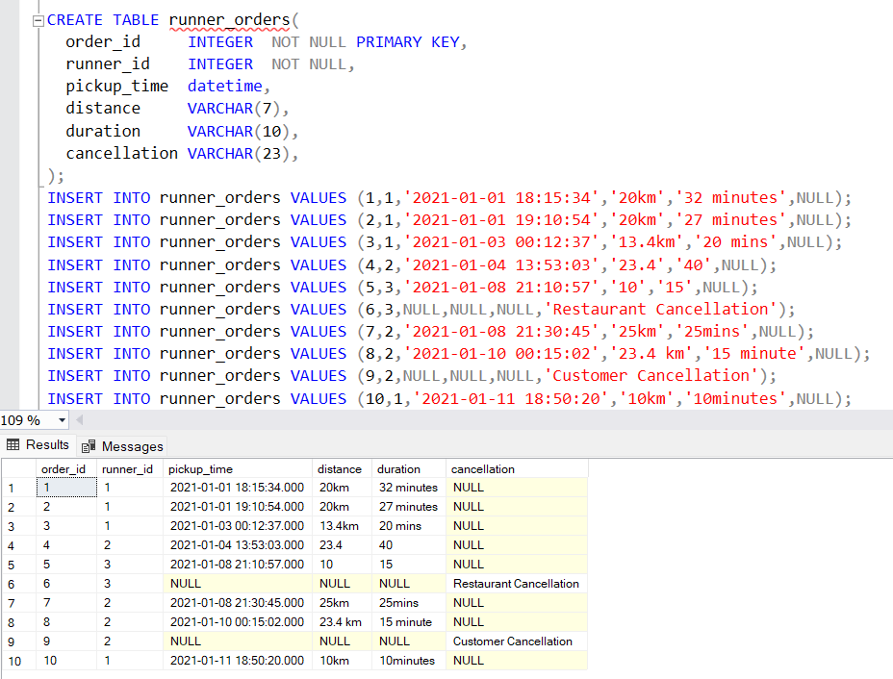

CREATE TABLE burger_runner(

runner_id INTEGER NOT NULL PRIMARY KEY

,registration_date date NOT NULL

);

INSERT INTO burger_runner VALUES (1,'2021-01-01');

INSERT INTO burger_runner VALUES (2,'2021-01-03');

INSERT INTO burger_runner VALUES (3,'2021-01-08');

INSERT INTO burger_runner VALUES (4,'2021-01-15');

CREATE TABLE customer_orders(

order_id INTEGER NOT NULL

,customer_id INTEGER NOT NULL

,burger_id INTEGER NOT NULL

,exclusions VARCHAR(4)

,extras VARCHAR(4)

,order_time datetime NOT NULL

);

INSERT INTO customer_orders VALUES (1,101,1,NULL,NULL,'2021-01-01 18:05:02');

INSERT INTO customer_orders VALUES (2,101,1,NULL,NULL,'2021-01-01 19:00:52');

INSERT INTO customer_orders VALUES (3,102,1,NULL,NULL,'2021-01-02 23:51:23');

INSERT INTO customer_orders VALUES (3,102,2,NULL,NULL,'2021-01-02 23:51:23');

INSERT INTO customer_orders VALUES (4,103,1,'4',NULL,'2021-01-04 13:23:46');

INSERT INTO customer_orders VALUES (4,103,1,'4',NULL,'2021-01-04 13:23:46');

INSERT INTO customer_orders VALUES (4,103,2,'4',NULL,'2021-01-04 13:23:46');

INSERT INTO customer_orders VALUES (5,104,1,NULL,'1','2021-01-08 21:00:29');

INSERT INTO customer_orders VALUES (6,101,2,NULL,NULL,'2021-01-08 21:03:13');

INSERT INTO customer_orders VALUES (7,105,2,NULL,'1','2021-01-08 21:20:29');

INSERT INTO customer_orders VALUES (8,102,1,NULL,NULL,'2021-01-09 23:54:33');

INSERT INTO customer_orders VALUES (9,103,1,'4','1, 5','2021-01-10 11:22:59');

INSERT INTO customer_orders VALUES (10,104,1,NULL,NULL,'2021-01-11 18:34:49');

INSERT INTO customer_orders VALUES (10,104,1,'2, 6','1, 4','2021-01-11 18:34:49');

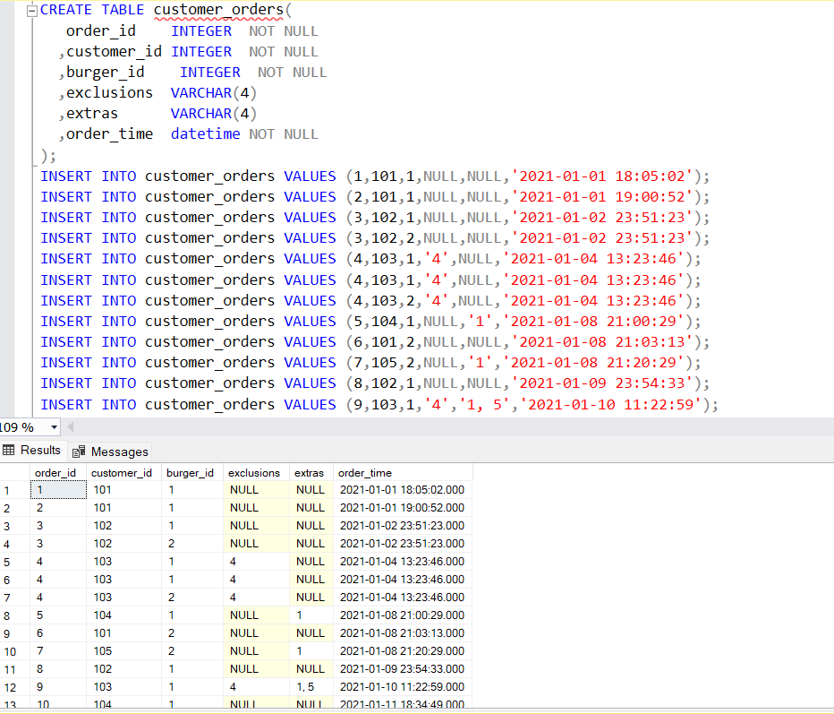

🡪 How many burgers were ordered?

SELECT COUNT(*) AS total_burgers_ordered

FROM customer_orders;

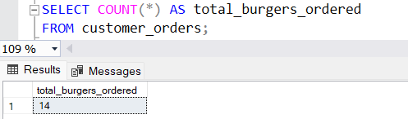

🡪 How many successful orders were delivered by each runner?

SELECT runner_id, COUNT(*) AS successful_orders

FROM runner_orders

WHERE cancellation IS NULL

GROUP BY runner_id;

🡪How many of each type of burger was delivered?

SELECT

bn.burger_name,

COUNT(co.burger_id) AS delivered_burger_count

FROM

customer_orders co

JOIN

runner_orders ro ON co.order_id = ro.order_id

JOIN

burger_names bn ON co.burger_id = bn.burger_id

WHERE

ro.cancellation IS NULL

GROUP BY

co.burger_id, bn.burger_name;

🡪What was the maximum number of burgers delivered in a single order?

SELECT TOP 1

co.order_id,

COUNT(co.burger_id) AS burger_count

FROM

customer_orders co

JOIN

runner_orders ro ON co.order_id = ro.order_id

WHERE

ro.cancellation IS NULL

GROUP BY

co.order_id

ORDER BY

burger_count DESC;

🡪What was the total volume of burgers ordered for each hour of the day?

SELECT

DATEPART(hour, co.order_time) AS order_hour,

COUNT(co.burger_id) AS total_burgers_ordered

FROM

customer_orders co

GROUP BY

DATEPART(hour, co.order_time)

ORDER BY

order_hour;

